


Year 10

Semester 2

Investigation 1

Statistical Investigation

Your task is to create an informative poster presentation based on the collection and interpretation of data towards addressing a practical research question for the topic: School Life

The poster will be completed in a small group of 2-3 people and all posters will be entered into a national competition. You are to create a poster (up to 84cm by 59cm) on a topic of your own choice. The poster may be presented in either a hard copy or a digital copy. It should be readable from 2 metres away. Your posters will be presented to the class before being sent away for judging in the SSAI competition.

Task Procedure
- Choose a topic question or problem that you will prove or answer using data.

- Complete a plan of action. Use the planning document attached to guide your project to completion.

- State your aim, hypothesis and give some background information.

- Collect the data you require. You MUST use ONLY secondary data sourced form a reliable source.

- Produce the data in a table of results.

- Display your data in appropriate graphical forms. (ie. histogram, comparative box plots, scatterplots, dot plot etc.)

- Analyse the data using appropriate techniques. (Mean, Mode, Media, range, IQR, Trend line, Correlation, Standard Deviation, etc)

- Discuss the findings of your data analysis clearly outlining any possible biases or outliers and how you have dealt with these issues.

- Complete your conclusion.

- Reference the any websites you used to access your data.

For further information about competition rules and also some great example;
https://www.ssaipostercomp.info/
Other useful website include;
http://www.abs.gov.au/
http://www.data-first.org/data-center/
https://easel.ly/blog/top-5-resources-finding-reliable-data/
https://www.gapminder.org
http://data.gov.au/
https://www.myschool.edu.au/
https://knoema.com/

Yr 10 Topic: School Life

The topic for Year 10 is School Life: Your task is to compare school life in South East Asia and Australia. To do this you will need to apply your knowledge of statistics to illustrate your response. Your investigation could analyze areas such as: daily start and end times, how many classes make up a day, how much time is spent in the classroom, average commute times, a comparison of the amount of homework issued, how technology is managed/used in the school setting, etc…

Some examples of questions you may try to answer could include;

- Does the amount of homework given in a country have any correlation with its academic performance?

- What are the main areas school life in Australia is similar to or different than in Asia?

- Are there any differences in the approach to using technology in the school?

- How involved are students in extra-curricular or school-based club activities?

- Do students in different countries have different worries or feel different pressures?

An example of what your project could look like;

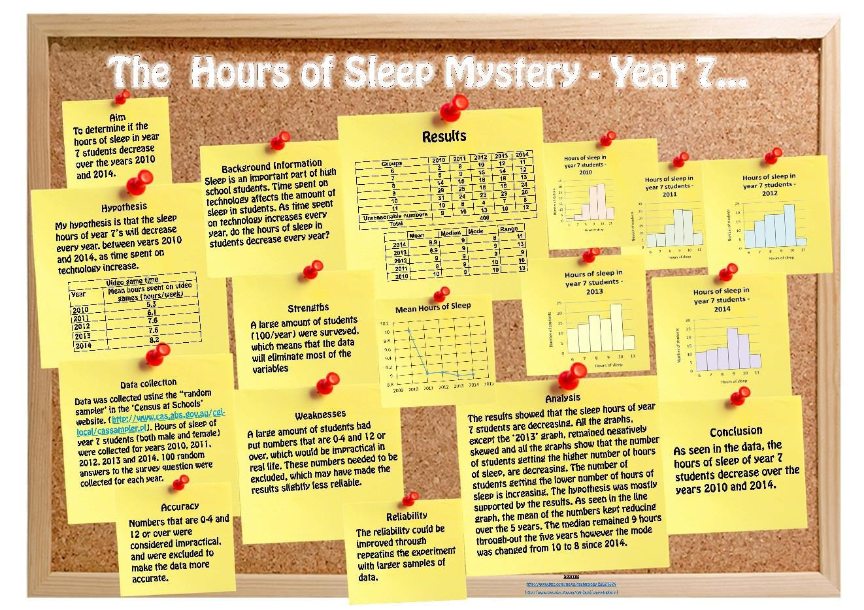

Planning Hints:

A well-considered plan will improve the likely value and success of your project.

Consider the following:

- What types of studies or areas of study may be of interest to you and your team, as well as to others viewing the poster. If it’s interesting to you, you’ll be more motivated to research it and produce a quality investigation.

- What is/are the key question/s you wish to address, or hypotheses to test? Can you quantify such hypotheses?

- Can quantitative data be obtained, within your personal constraints and those of the project, that will help you to answer such questions or hypotheses?

- Should, or could, you involve comparisons of groups (e.g., males versus females; between classes; etc.) and in what ways may the groups be compared? This may raise the interest of your project

- If someone else repeated your project would they obtain the same or similar results? Are you attempting to make some generalisations based on a sample?
  - How have you considered variation?
  - How generalised are your results?
- Are you measuring what you intended to measure and need to measure?

- Has everyone involved in collecting data used the same method of measurement and is it the best measure?
  - Why did you measure in a particular way?

- Are you best to report something graphically or via text?
  - does your graph provide a clear message or is it hard to interpret?

- How strong are your conclusions and have you noted limitations and why you were unable to overcome them?

- Is your poster presentation adequately simple and informative?

- Have you used clear headings?

POSTER CHECKLIST

- Clarity of the message:
  - Is the poster understandable without extra information?
  - Are the objectives, research question or hypotheses clear?
  - Are the results and conclusions clear?
  - Is the poster clearly and logically set out?

- Data collection:
  - Are the collected data appropriate for answering the research question?
  - Are the data collection methods clearly stated? (e.g., Secondary sources are cited — published reports, databases etc.)
  - Has quality of the data been considered? (i.e., accuracy of measurements, size of the sample, reliability of sources, methods of sampling, etc.)
  - Has variation been considered when obtaining data?
  - Have comparison groups been considered and well-constructed where applicable?
  - Are the data sources referenced in the poster?
  - Are the survey questions included in the table of results?
  - Has bias in your survey question or sample group been considered?

- Graphs and tables:
  - Are the graphs/tables/statistics appropriate for displaying and summarising the data?
  - Are there adequate graphs/tables from different perspectives?
  - Does every graph/ table add something to the poster?
  - Are the graphs/tables properly titled and explained?

- Calculations
  - Have you included appropriate statistical calculations? (ie mean, mode, median, range, Quartiles, IQR, calculate outliers etc)

- Analysis and conclusions
  - Are the data analysed in terms of the research question or hypotheses?
  - Is the analysis appropriate for the kind of data collected?
  - How well is the research question answered?
  - Are there conclusions and are they supported by the data?
  - Are there any limitations discussed or improvements for future studies suggested?

- Presentation:
  - Is the poster readable from 2 metres (7 feet) away?
  - Is there a good balance between graphs and text?
  - Does the poster look neat?

- Creativity/importance:
  - Is the research question creative, original?
  - Can the study answer an interesting question?
  - Is the design creative and original?
  - Is the poster eye-catching?

- Oral Presentation of your group project:
  - Are you prepared to present the poster to the rest of the class

